**A Course Project Submitted to**

**Department of Computer Science and Information Systems**

**College of Arts and Sciences**

**American University of Kuwait**

**In Partial Fulfilment of the Requirements for the**

**Mobile Computing Course – CSIS 401**

**The Nim Game  
Application**

**By**

**Abrar AlFailakawi, s00036020 – Computer Science**

**Advisor**

**Dr. Iyad Abu Doush**

**Course Instructor**

**Dr. Iyad Abu Doush**

**21, May 2020**

**Spring, 2020**

# **TABLE OF CONTENTS**

Contents

❖ **Abstract** 2

❖ **Introduction** 2

- **Motivation** 2

- **System Overview** 3

❖ **Mobile Application Design.** 3

- **System features** 3

- **User interface** 3

❖ **User interface screens for the of the Nim game application** 6

❖ **Use case of the application** 10

❖ **Class Diagram of the Application** 13

- **Classes with Data Members and Methods** 14

❖ **CONCLUSIONS** 17

❖ **REFERENCES** 18

\

# **Abstract**

The report is talking about “The Nim Game” application. It gives a brief description of the motivation behind choosing to create the Nim application, and the scope of it. The report also describes the User Interface (UI) and functionalities of the application, provides the user interface screens developed, and shows UI Wireframe and hierarchy of screens. Moreover, the system requirements are included in the report by showing the system functions, and the designs using UML use case diagrams, class diagrams of the application .Additionally, the result of the project are given by including classes with data members, and describe the methods that have been used for the application. To conclude, a reflection on the whole project is delivered.

# **Introduction**

## **Motivation**

The motivation in developing, “The Nim game” comes from some reasons. First point, most games depend on luck, and there are few that need thinking and strategies to play it. Nim game is one of an ancient game which if you play smartly, you are assured to win. In general, the Nim game is a mathematical game of strategy in which two players take turns removing objects as matchsticks, or stones from different piles. On each turn, a player must remove at least one object, and may remove any number of objects provided they all come from the same pile. To win the game the players must avoid taking the last object. Therefore, it’s all about figuring out the winning strategy. The game will improve player’s skills in understanding of binary numbers, since it is the winning tactic. Players are required to know how to use the binary operation (XOR) in order to win. Therefore, it is good to have a game that you can guaranteed to win by learning about mathematical theory!

## **System Overview**

The objective of the project is to build, and implement, “The Nim Game” application for entertainment use. The project is basically a game that provides the players a challenging mathematical game. From two type of categories, and levels.

Users can enjoy the game by playing Vs. an AI (Computer) or with other real player. Each turn the player must pick one or more objects that exists on the same row. The last person who pick the last objects, loses!

# **Mobile Application Design.**

## **System features**

The Nim game application are being developed and implemented by using Android Studio. The application doesn’t require a database system. The application has a two options to start and create a new game. Besides, player who chooses to play against an AI can specify his/her preferred level of the game.

## **User interface**

Figure below shows the UI Wireframe and hierarchy of The Nim Game application screens.

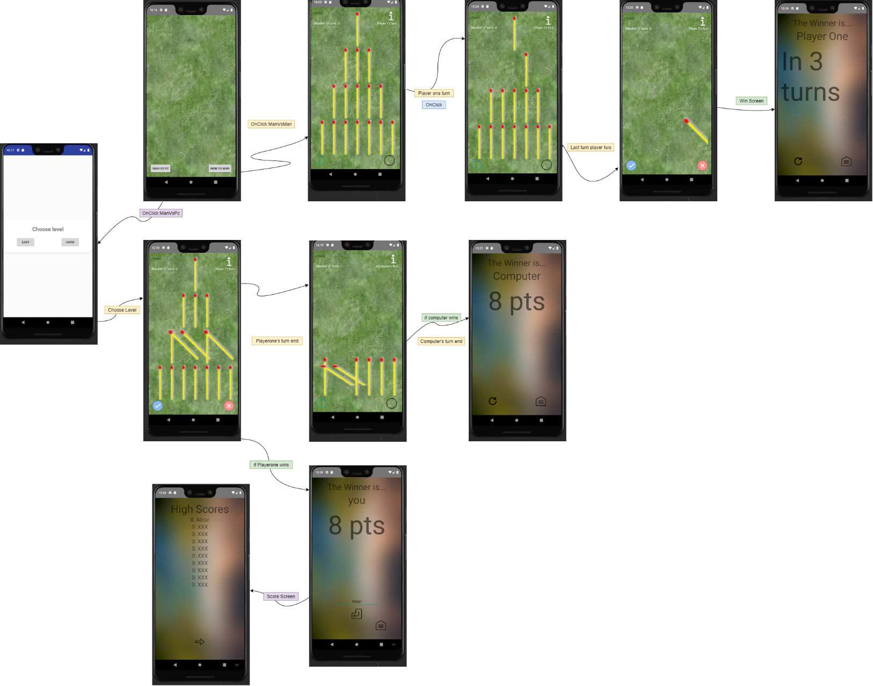

# **User interface screens for the of the Nim game application**

* **Main screen:** user can choose between Man vs. PC, or two player’s option.

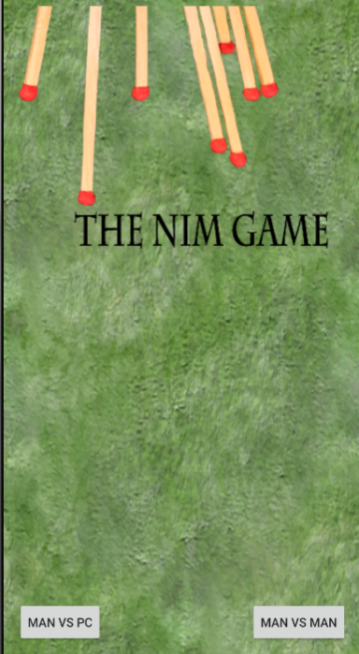

* **Man vs. Pc Mode**: when the user click on the MAN VS PC button, a popup window that has a TextView, and two buttons. The player can choose the game difficulty (easy, or hard.) The game will be between the user and the computer.

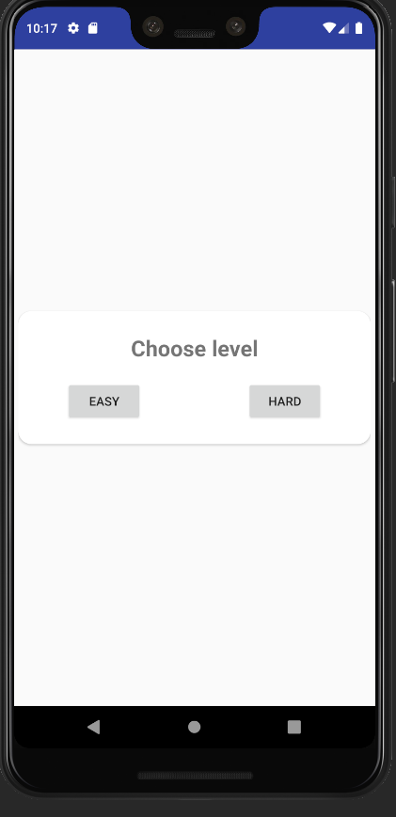

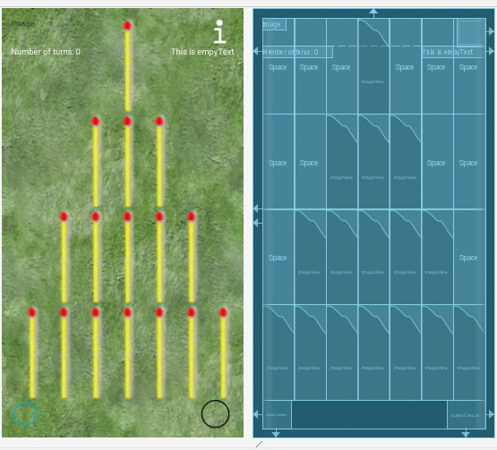

* 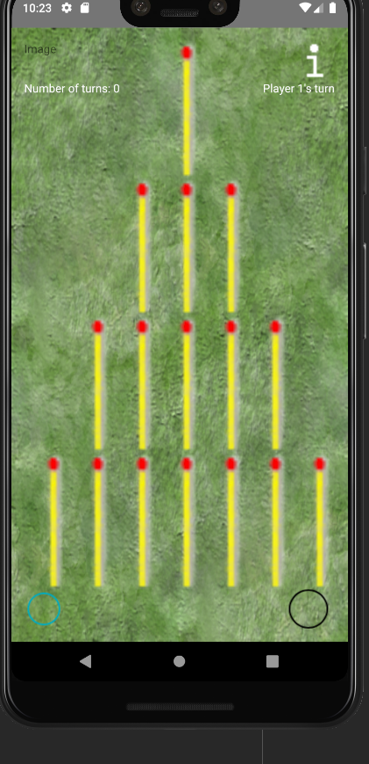**MAN Vs. MAN option:** The players can generate a game between two players.

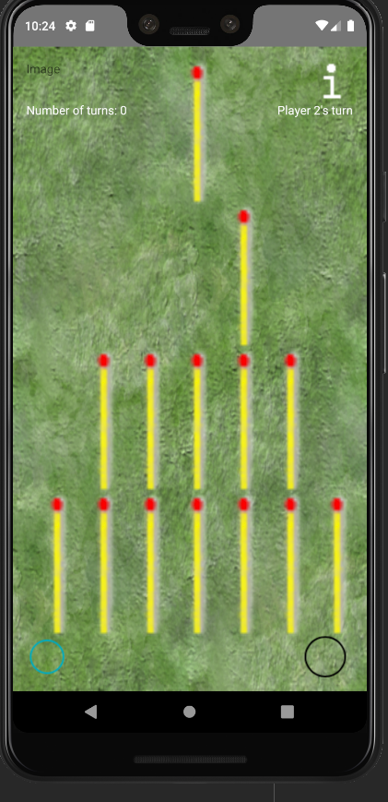

* 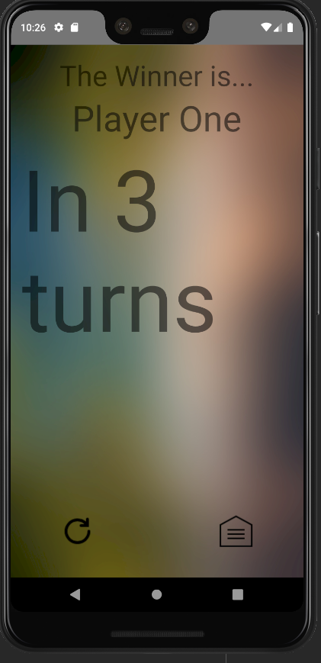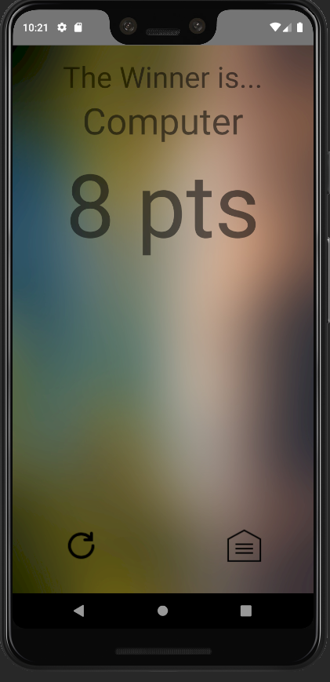**Win and score screens:** it displays the name of the player and his/her top scores.

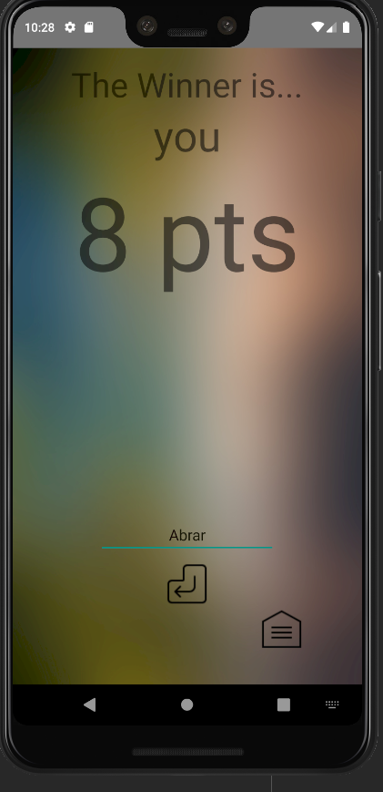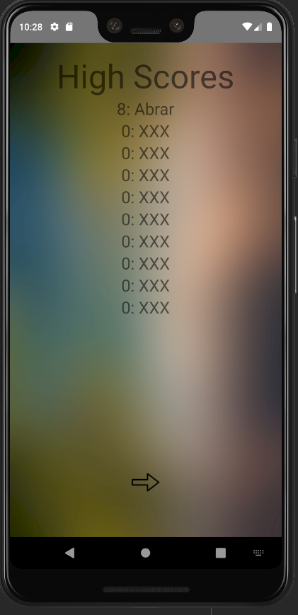

- **Information screen:** it’s a fragment will generated when the user click on the “I” button. The layout has only a TextView. it shows a brief explanation of the game, and the name of the developer.

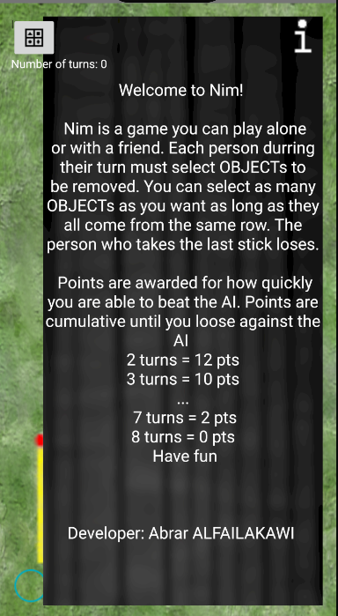

# **Use case of the application**

* Main Screen use case diagram

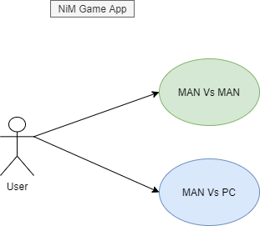

* Man Vs. Man Game use case diagram

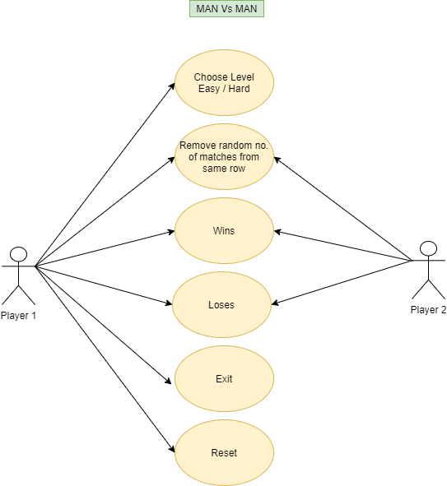

* Man Vs. PC Game use case diagram

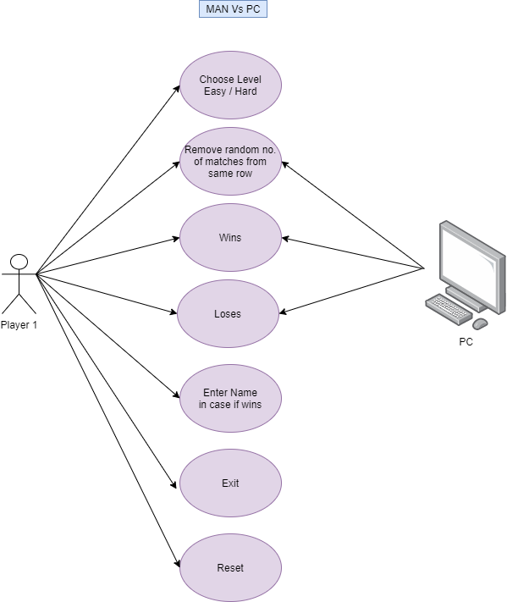

# **Class Diagram of the Application**

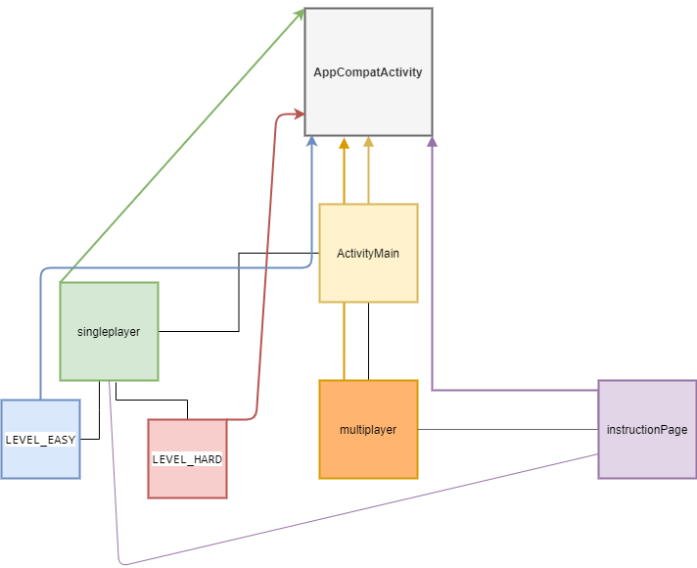

## **Classes with Data Members and Methods**

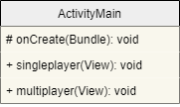

* **ActivityMain**: a class that handles and displays the main screen for the user. Includes two options for the player to choose.

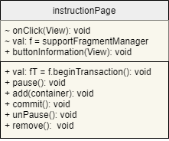

* **instructionPage**: a fragment class that has onClick function with support fragment Manager value, using an xml file. It displays the instruction of how to play the game, and the name of the developer. The button exists on singleplayer layout, and multiplayer layout. The user can click on it to display the (iPage). It has if condition.

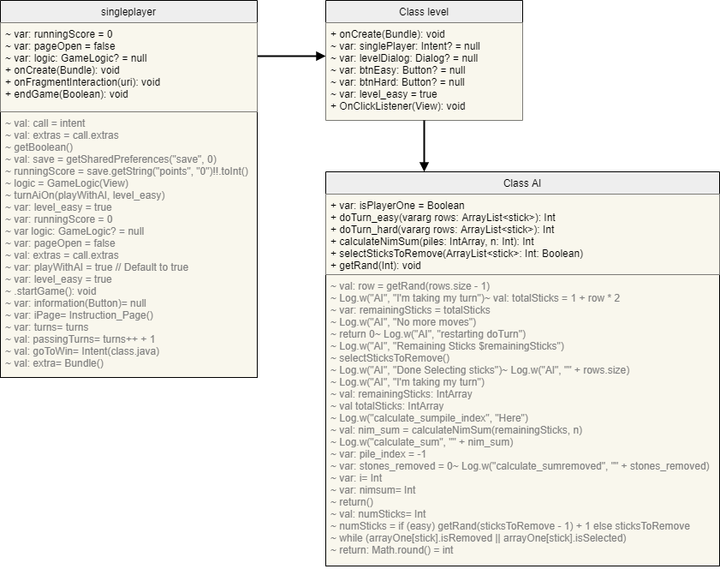

* **singleplayer:** a class that is displayed when the user chooses to play against the computer (Man Vs. PC). It allows the user to choose the level difficulty (intent: pop-up layout) of the game to play against the computer. The class AI explain the methods of playing with the computer, who start first, which stick/row is chosen, and explain how the matches decrease in the array.

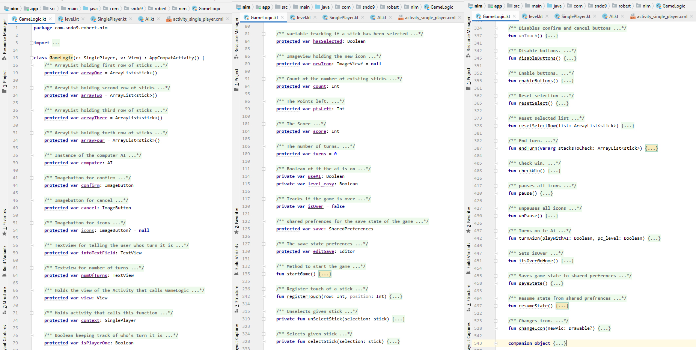

**The figure above shows the game logic and the methods are used for oneplayer class**

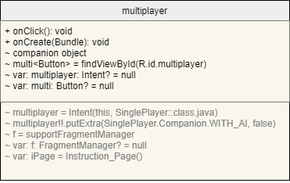

* **Multiplayer:** a class that is displayed when the user chooses to play against a friend (two players).

# **CONCLUSIONS**

The process of building the project is helping me to improve my coding, and implementation skills in Android Studio, and learning a new programming language Kotlin. Although the program had few errors, and mistakes during the first phase, I have learned how to manage my time, cope with the tasks, and be more responsible to achieve the best outcome for the project by searching for more sources and reference to explore more codes for Kotlin programming language. In the end, I’ve developed my learning and skills in dealing with Android Studio functionalities through this hard time, and shifting from in campus learning to E-learning.

# **REFERENCES**

[01] Doush, Iyad T. (2020), Class Notes and Supplements, Mobile Computing CSIS 401, Department of Computer Science and Information Systems, American University of Kuwait, Spring-2020…